$$WACC=((E/V)×Re)+((D/V)×Rd×(1-Tc))$$

WACC = 18.69% means KPC must earn at least 18.69% per year on its capital to satisfy its investors, and any future cash flow is discounted heavily — which is why a high-WACC DCF will likely produce a value below the KES 9.00 IPO price.

RED FLAG: Based on the FY2025 financials in the Information Memorandum, KPC earns a return on equity of about 7.6% and a return on invested capital of about 9.3%. Both are far below the WACC of 18.69%.
A company creates value only when it earns more than its cost of capital. On FY2025 numbers, KPC did not. It means the company was not covering its cost of capital according to historical book value. The IPO price of KES 9.00 implied an earnings yield of only 4.58%, which was far below even the Kenyan risk-free rate of 12.64%.
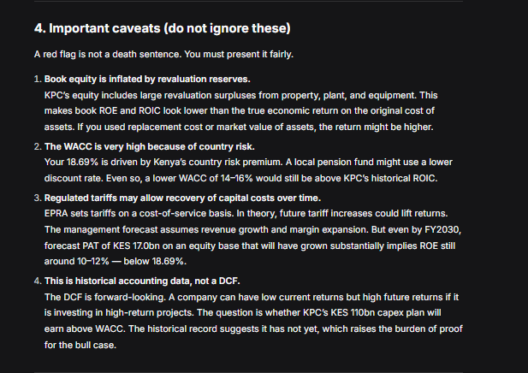
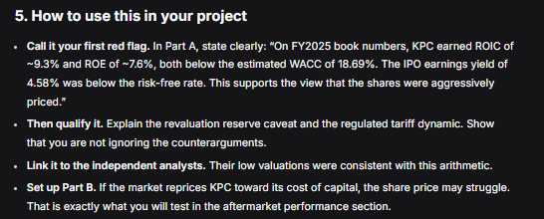
The counterintuitive insight: At WACC = 18.69%, higher growth (g = 5%) gives a lower value (KES 1.52) than lower growth (g = 3%, KES 1.85). This is because ROIC (10%) < WACC (18.69%). When a company earns less than its cost of capital, growth destroys value. Every shilling reinvested earns 10% but costs 18.69%.

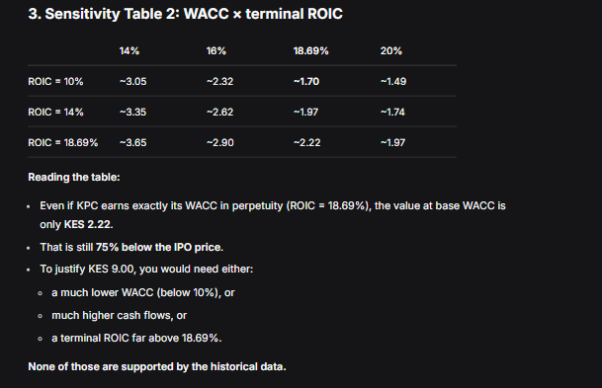
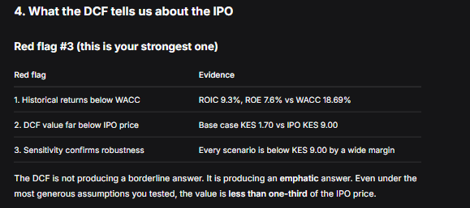
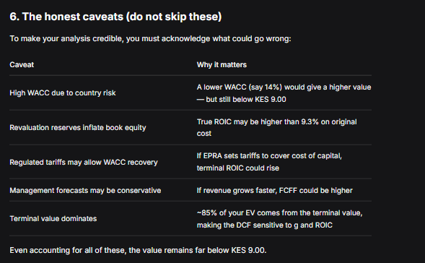

DCF says KPC was worth roughly KES 1.70–2.20 per share at IPO, not KES 9.00 — and that conclusion holds across every reasonable set of assumptions.
DCF SUMMARY
A DCF using a WACC of 18.69% values KPC at KES 1.70 per share — 81% below the KES 9.00 IPO price. Sensitivity analysis across WACC, terminal growth, and terminal ROIC never produces a value above KES 3.65, and even the most generous scenario tested reaches only KES 2.22.
The gap is structural: KPC earns 9.3% on invested capital, well below its 18.69% cost of capital, so growth destroys value rather than creating it.

